**Unit 2-Multiple Linear Regression and Classification(ML)**

**Multiple Linear Regression:**

Multiple linear regression is a statistical technique used to model the relationship between a dependent variable and multiple independent variables. It extends the concept of simple linear regression, where only one independent variable is used, to incorporate several predictors.

**In** multiple linear regression, the goal is to find the best-fitting linear equation that describes the relationship between the dependent variable and the independent variables. The equation takes the form:

* Y = β0 + β1X1 + β2X2 + ... + βnXn + ε

Where:

* Y is the dependent variable (also known as the response variable or target variable).
* X1, X2, ..., Xn are the independent variables (also known as predictor variables or features).
* β0, β1, β2, ..., βn are the coefficients or parameters that represent the effect of each independent variable on the dependent variable.
* ε is the error term, representing the unexplained variability in the data.

The coefficients β0, β1, β2, ..., βn are estimated using a technique called ordinary least squares (OLS) regression, which minimizes the sum of squared differences between the observed and predicted values of the dependent variable. **Multiple linear regression** is useful for various purposes, such as predicting house prices based on features like size, number of bedrooms, and location, or estimating sales based on advertising expenditure, pricing, and other factors.

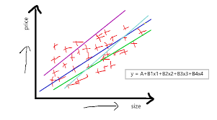

**Classification:**

Classification is a machine learning task that involves assigning categorical labels or classes to input data based on its characteristics or features. The goal is to learn a decision boundary or a mapping function that can accurately classify new, unseen instances into predefined categories.

**There** are several classification algorithms available, including logistic regression, decision trees, support vector machines (SVM), random forests, and neural networks. Each algorithm has its own strengths, weaknesses, and assumptions, and the choice of algorithm depends on the specific problem and the nature of the data.

The process of classification typically involves the following steps:

1. Data Preparation: Collect and preprocess the data, including cleaning, normalization, and feature extraction.
2. Feature Selection: Identify the most relevant features that contribute to the classification task.
3. Training: Use a labeled dataset to train the classification model by adjusting its parameters or finding the optimal decision boundary.
4. Evaluation: Assess the performance of the trained model using evaluation metrics such as accuracy, precision, recall, and F1 score.
5. Prediction: Apply the trained model to classify new, unseen instances.

Classification is widely used in various domains, such as spam filtering, sentiment analysis, image recognition, medical diagnosis, and credit scoring, among others.

**Estimating the Regression Coefficients**

To estimate the regression coefficients in multiple linear regression, you can use the method of ordinary least squares (OLS). The OLS method aims to find the values of the coefficients that minimize the sum of squared differences between the observed values of the dependent variable and the predicted values from the regression equation.

Here's a step-by-step process for estimating the regression coefficients:

1. Data Preparation: Collect and preprocess your data, ensuring that you have a dataset with the dependent variable and multiple independent variables.
2. Model Specification: Determine the form of the multiple linear regression model by specifying the dependent variable and the independent variables. The model will have the form:

Y = β0 + β1X1 + β2X2 + ... + βnXn + ε

* Where Y is the dependent variable, X1, X2, ..., Xn are the independent variables, β0, β1, β2, ..., βn are coefficients to be estimated, and ε is the error term.

1. Estimation: Use the OLS method to estimate the regression coefficients. This involves finding the values of the coefficients that minimize the sum of squared residuals. The sum of squared residuals is calculated as the sum of the squared differences between the observed values of the dependent variable and the predicted values from the regression equation.

* Mathematically, the OLS estimation can be represented as:
* β = (X^T X)^(-1) X^T Y
* Where β is a vector of the estimated coefficients, X is the matrix of independent variables (with an additional column of ones for the intercept term), X^T is the transpose of X, and Y is the vector of the dependent variable.
* This equation gives you the estimated values for β0, β1, β2, ..., βn.

1. Interpretation: Interpret the estimated coefficients. Each coefficient represents the expected change in the dependent variable for a one-unit change in the corresponding independent variable, holding all other variables constant.
2. Evaluation: Assess the quality of the regression model by examining statistical metrics such as the coefficient of determination (R-squared), adjusted R-squared, p-values, and confidence intervals for the coefficients. These metrics help evaluate the significance and goodness-of-fit of the model.

It's worth noting that the OLS method assumes certain assumptions about the data, such as linearity, independence of errors, and homoscedasticity. Violations of these assumptions can affect the accuracy and reliability of the estimated coefficients.

**Other Considerations in the Regression Mode**

When building a regression model, in addition to estimating the regression coefficients, there are several other considerations that you should take into account to ensure the model's accuracy and reliability. Here are some important factors to consider:

1. Model Assumptions: Validate the assumptions of the regression model. The most common assumptions include linearity, independence of errors, homoscedasticity (constant variance of errors), and normality of errors. Violations of these assumptions may affect the reliability of the estimated coefficients and the validity of statistical tests.
2. Multicollinearity: Check for multicollinearity, which occurs when independent variables are highly correlated with each other. Multicollinearity can make it difficult to interpret the effects of individual variables and can lead to unstable coefficient estimates. Detecting and addressing multicollinearity is important for reliable results.
3. Model Fit and Evaluation: Assess the overall fit of the model and evaluate its performance. Common evaluation metrics include the coefficient of determination (R-squared), adjusted R-squared, and root mean square error (RMSE). These metrics help assess how well the model fits the data and how much of the variance in the dependent variable is explained by the independent variables.
4. Outliers and Influential Points: Identify outliers, which are observations that deviate significantly from the overall pattern of the data. Outliers can have a substantial impact on the estimated coefficients and model performance. Additionally, identify influential points that have a strong influence on the regression results. Robust regression techniques or outlier removal strategies may be employed to mitigate their effects.
5. Variable Selection: Select the most relevant independent variables for your model. Consider using techniques such as forward selection, backward elimination, or stepwise regression to identify the subset of variables that contribute the most to the model's predictive power. Variable selection helps prevent overfitting and improves model interpretability.
6. Cross-Validation: Validate the model's performance using cross-validation techniques. Split your data into training and testing sets or employ techniques such as k-fold cross-validation to assess the model's ability to generalize to unseen data. This helps evaluate the model's robustness and avoids overfitting.
7. Residual Analysis: Examine the residuals (the differences between the observed and predicted values) to check for patterns or systematic deviations. Plotting the residuals against the predicted values or the independent variables can reveal any remaining structure in the data that the model has not captured. Residual analysis helps identify potential model misspecification or violations of assumptions.

**Comparison of Linear Regression with K-Nearest Neighbours**

Linear Regression and k-Nearest Neighbors (k-NN) are two different approaches used in supervised machine learning, but they have distinct characteristics and applications. Here's a comparison of Linear Regression and k-Nearest Neighbors:

|  | **Linear Regression** | **k-Nearest Neighbors** |
| --- | --- | --- |
| Model Type | Parametric | Non-parametric |
| Interpretability | Provides interpretable coefficients | Less interpretable |
| Complexity and Flexibility | Assumes linear relationship, can handle nonlinearity with extensions | Flexible, can capture complex nonlinear relationships |
| Training and Prediction | Requires estimation of coefficients | No explicit training, calculates distances during prediction |
| Handling Categorical Variables | Requires encoding categorical variables | Can handle categorical variables directly |
| Overfitting | Prone to overfitting with complex models or multicollinearity | Prone to overfitting, sensitive to choice of k |
| Dataset Size | Efficient for large datasets | Computationally expensive for large datasets |
| Application | Suitable for problems with linear relationships | Suitable for capturing complex patterns |

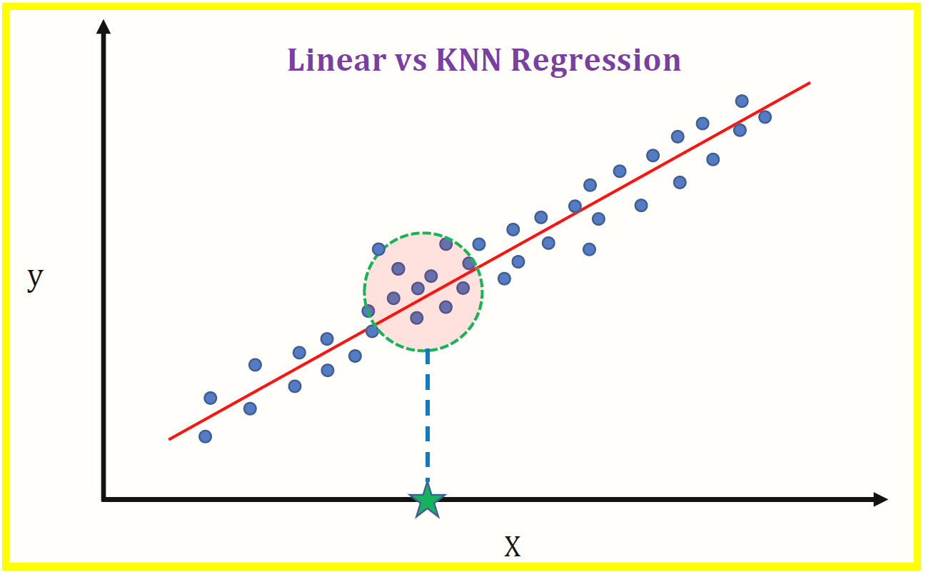

**Classification: An Overview of Classification**

Classification is a supervised learning technique in machine learning that involves assigning categorical labels or classes to input data based on their characteristics or features. The goal of classification is to learn a decision boundary or a mapping function that can accurately classify new, unseen instances into predefined categories.

Here's an overview of the classification process:

1. Data Preparation: Collect and preprocess the data for classification. This involves gathering labeled training data, cleaning the data, and performing any necessary preprocessing steps such as normalization, feature scaling, or feature extraction.
2. Feature Selection: Identify the relevant features that will be used as inputs to the classification model. Feature selection aims to choose the most informative and discriminative features that contribute to the classification task while eliminating irrelevant or redundant ones.
3. Training Data Split: Split the labeled data into two subsets: a training set and a validation set. The training set is used to train the classification model, while the validation set is used to assess its performance and tune hyperparameters.
4. Model Selection: Choose an appropriate classification algorithm or model. There are various algorithms available for classification, including logistic regression, decision trees, support vector machines (SVM), random forests, naive Bayes, and neural networks. The choice of model depends on the specific problem, data characteristics, and trade-offs between interpretability, performance, and computational complexity.
5. Model Training: Train the chosen classification model using the labeled training data. The model learns the patterns and relationships in the training data to create a decision boundary or a mapping function that can differentiate between different classes.
6. Model Evaluation: Assess the performance of the trained model using evaluation metrics such as accuracy, precision, recall, F1 score, and area under the receiver operating characteristic curve (ROC AUC). These metrics help measure how well the model predicts the correct class labels for both the training and validation datasets.
7. Hyperparameter Tuning: Adjust the hyperparameters of the classification model to optimize its performance. Hyperparameters are configuration settings that are not learned from the data but impact the behavior and performance of the model. Techniques like grid search or random search can be used to find the optimal combination of hyperparameters.
8. Model Deployment and Prediction: Once the classification model is trained and evaluated, it can be deployed for making predictions on new, unseen instances. The model takes the features of the unseen instances as input and predicts their corresponding class labels based on the learned decision boundary or mapping function.

Classification is widely used in various domains, including spam filtering, sentiment analysis, image recognition, text classification, fraud detection, medical diagnosis, and customer segmentation, among others.

**Why Not Linear Regression? Logistic Regression**

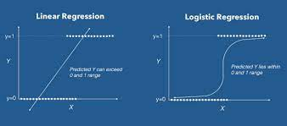

While linear regression is a powerful and widely used technique, it is not always suitable for classification tasks. Here are some reasons why linear regression may not be appropriate for classification:

1. Output Nature: Logistic regression is specifically designed for binary classification or multi-class classification problems. It models the probability of an instance belonging to a certain class, producing a predicted probability value between 0 and 1. This probability can then be used to make class predictions based on a chosen threshold.
2. Nonlinearity: Logistic regression models the relationship between the input features and the log-odds of the outcome variable using a logistic function (also known as the sigmoid function). This allows logistic regression to capture nonlinear relationships between the features and the class probabilities, making it more flexible and suitable for classification tasks.
3. Decision Boundary: Logistic regression provides a clear decision boundary that separates different classes. By choosing an appropriate threshold (e.g., 0.5), instances with predicted probabilities above the threshold are classified as one class, while those below are classified as another class. This makes logistic regression well-suited for drawing a distinction between classes.
4. Interpretability: Similar to linear regression, logistic regression provides interpretable coefficients that represent the impact of each feature on the log-odds of the outcome variable. These coefficients can be used to understand the direction and relative importance of the features in influencing the classification decision.
5. Class Probability Estimation: Logistic regression allows estimation of class probabilities, which can be useful for applications where knowing the confidence or likelihood of a prediction is important. This is particularly beneficial in scenarios where decision-making is based on the predicted probabilities rather than binary class labels.
6. Robustness to Outliers: Logistic regression is generally more robust to outliers compared to linear regression. Outliers in the data can have a substantial impact on the estimated coefficients in linear regression, but in logistic regression, the impact is usually mitigated due to the logistic transformation.
7. Handling Class Imbalance: Logistic regression can handle class imbalance by adjusting the class weights or using techniques like stratified sampling. This helps in cases where one class is significantly more prevalent than the others, ensuring that the model is not biased towards the majority class.
8. Widely Used and Well-Studied: Logistic regression is a well-established and widely used classification algorithm. It has been extensively studied, and there are well-developed techniques for model evaluation, regularization, and dealing with issues such as multicollinearity.

**Generative Models for Classification**

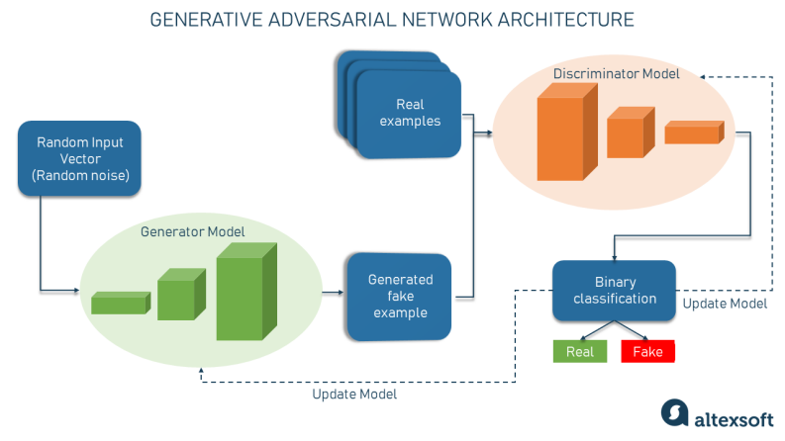

Generative models are a class of machine learning models that aim to model the underlying probability distributions of the data. They learn the joint distribution of the input features and the class labels and use this knowledge to generate new data samples. In the context of classification, generative models can be used to model the class-conditional distributions and estimate the posterior probability of each class given the input features.

Here are two popular generative models used for classification:

1. Naive Bayes:

Naive Bayes is a simple yet powerful generative classifier based on Bayes' theorem and assumes that the features are conditionally independent given the class label. Despite this "naive" assumption, Naive Bayes often performs well and is computationally efficient.

The algorithm calculates the posterior probability of each class given the features using Bayes' theorem and then predicts the class with the highest probability. Naive Bayes models are trained by estimating the class prior probabilities and the class-conditional probability distributions using maximum likelihood estimation or other techniques.

1. Gaussian Mixture Models (GMM):

Gaussian Mixture Models are generative models that assume the data is generated from a mixture of Gaussian distributions. Each component in the mixture model represents a class, and the model learns the parameters (mean and covariance) of each Gaussian component for each class.

During training, GMM estimates the class priors and the parameters of the Gaussian distributions using techniques such as the expectation-maximization (EM) algorithm. To classify new instances, GMM calculates the likelihood of the features belonging to each class and assigns the instance to the class with the highest likelihood.

Generative models have the advantage of being able to generate synthetic samples from the learned probability distributions, providing insights into the data generation process. They can handle missing data and can work well in cases with limited training data. However, they may make strong assumptions about the data distribution and independence of features, which may not always hold true in practice.

**A Comparison of Classification Methods**

1. Logistic Regression:

* Type: Parametric
* Assumptions: Assumes a linear relationship between features and the log-odds of the outcome variable.
* Interpretability: Provides interpretable coefficients representing the feature effects.
* Flexibility: Can handle both binary and multiclass classification problems.
* Performance: Performs well with linearly separable or close-to-linearly separable data, but may struggle with complex nonlinear relationships.
* Pros: Interpretable, computationally efficient, handles feature importance, handles class imbalance.
* Cons: Assumes linearity, limited in handling complex nonlinear relationships.

1. Decision Trees:

* Type: Non-parametric
* Assumptions: Makes no specific assumptions about the data distribution.
* Interpretability: Provides a hierarchical structure of decisions for classification.
* Flexibility: Can handle both binary and multiclass classification problems and can capture complex interactions.
* Performance: Can be prone to overfitting, especially with deep trees, but can be regularized using pruning techniques.
* Pros: Interpretable, handles both numerical and categorical data, captures interactions, handles feature importance.
* Cons: Prone to overfitting, sensitive to small variations in the data.

1. Random Forests:

* Type: Ensemble method combining multiple decision trees
* Assumptions: Builds on decision trees, making no specific assumptions about the data distribution.
* Interpretability: Provides feature importance measures based on the ensemble of trees.
* Flexibility: Can handle both binary and multiclass classification problems and can capture complex interactions.
* Performance: Reduces overfitting compared to individual decision trees and offers better generalization.
* Pros: Handles overfitting, robust to noise and outliers, handles feature importance.
* Cons: Less interpretable than a single decision tree, computationally more expensive.

1. Support Vector Machines (SVM):

* Type: Margin-based classifier
* Assumptions: Assumes a clear linear or nonlinear separation between classes.
* Interpretability: Provides a decision boundary with support vectors.
* Flexibility: Can handle both binary and multiclass classification problems using different kernels.
* Performance: Performs well in high-dimensional spaces, but can be computationally expensive for large datasets.
* Pros: Effective in capturing complex relationships, works well with high-dimensional data, handles class imbalance.
* Cons: Less interpretable, computationally expensive for large datasets.

1. k-Nearest Neighbors (k-NN):

* Type: Instance-based classifier
* Assumptions: Makes no specific assumptions about the data distribution.
* Interpretability: No explicit interpretability, relies on the nearest neighbors for classification.
* Flexibility: Can handle both binary and multiclass classification problems, sensitive to the choice of k.
* Performance: Simple and intuitive, performs well in local neighborhoods but can struggle with high-dimensional data.
* Pros: Handles complex relationships, easy to understand and implement, handles class imbalance.
* Cons: Computationally expensive for large datasets, sensitive to the choice of k

